|  |  |  |
| --- | --- | --- |
| Year 11 Physics – Validation Test 1 Ans  Latent heat | | |
|  | | |
| **Name:** | **Teacher:** | **Score /15** |
| **Comment:** | | |

1. Define the term “Latent Heat”.

|  |
| --- |
| Latent heat is the amount of energy per kg (unit mass) that is absorbed or released during a phase change without change in temperature.***(1)*** |
|  |

**[2 Marks]**

1. Explain in terms of internal energy why the temperature does not increase during a change of phase?

|  |
| --- |
| Temp is α Av KE, as T does not increase Av KE = Constant, KE = constant (2) |
| Energy goes into PE, increasing bond energy. (2) |
|  |
|  |
|  |
|  |
|  |

**[ 4 marks]**

1. A student conducted a similar experiment to the one that you did, but used a polystyrene cup instead of a calorimeter to hold the mixture. For the purpose of this question, you may assume the cup did not absorb any heat and its mass has already been removed from the results below.

Use the student’s partial data to calculate the experimental value for the latent heat of fusion of ice.

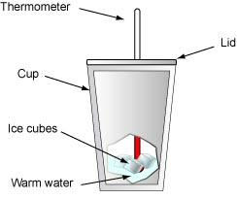

|  |  |
| --- | --- |
| Mass of Water in cup | 200g |
| Mass of Water plus ice in cup | 225g |
| Mass of ice |  |
| Initial temp (ice) | 0º C |
| Initial temp (water) | 50 º C |
| Final temp (water) | 35 º C |
| c (water) | 4180 J kg-1K-1 |
| c (ice) | 2100 J kg-1K-1 |

**[5 Marks]**

$$Heat lost=Heat Gained$$

$$mc∆T \left(water\right)=mLf \left(ice\right)+ mc∆T (iced water)$$

$$0.200 x 4180 x \left(50-35\right)=0.025 x L+0.025 x 4180 \left(1 for using 4180\right) x \left(35-0\right)$$

$$12540 \left(1\right)=0.025 L+ 3657.5 (1)$$

$$8882.5=0.25 L$$

$$L=\frac{8882.5}{0.25}$$

$$L=35530 J kg^{-1}K^{-1} (1)$$

$$L=3.55 x {10}^{5} J kg^{-1}K^{-1} (1)$$

NOTE - Incorrect units or more than 3 SF = ***(-1 each)***

1. An ice cube is in the fridge at a temperature of -10 $°$ C. Heat is applied to the ice cube. Assuming heat is applied at a constant rate draw the heating curve showing the ice cube increasing in temperature from -10 $°$ C to steam at 120 $°$ C. Label each section of the graph and show the appropriate formulas.

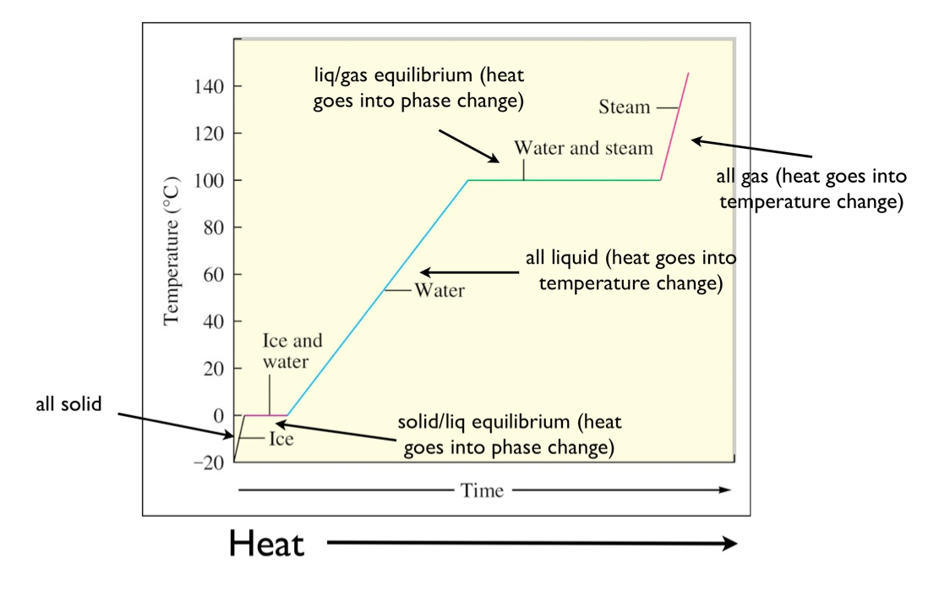

Heating ice: 

Change of phase ice to water: 

Heating water : 

Change of phase water to gas: 

Heating steam: 

General shape of graph and correct labelling (2)

Length Lv greater than Lf (1)

Correct equations (2)